Sarah,

It was great to meet with you and I hope you learned a lot.

I included diagrams of the ‘triangle of youth’ to illustrate the technique that I showed you.

Finally, I illustrated where we put dark and light foundation on your specific face shape. The male face has a much higher forehead than you do so you would only darken a slight amount around the forehead.

Every brush that I reference in the directions is included in the brush sets that I recommend, and I encourage you to use the size and shape brush that works best for you. My suggestions are just starting points.

Let me know if I’m forgetting anything that we talked about and of course, I’m always here for any additional product or technique tips!

Xoxo,

Laura
Triangle of Youth (Female Face Shape)
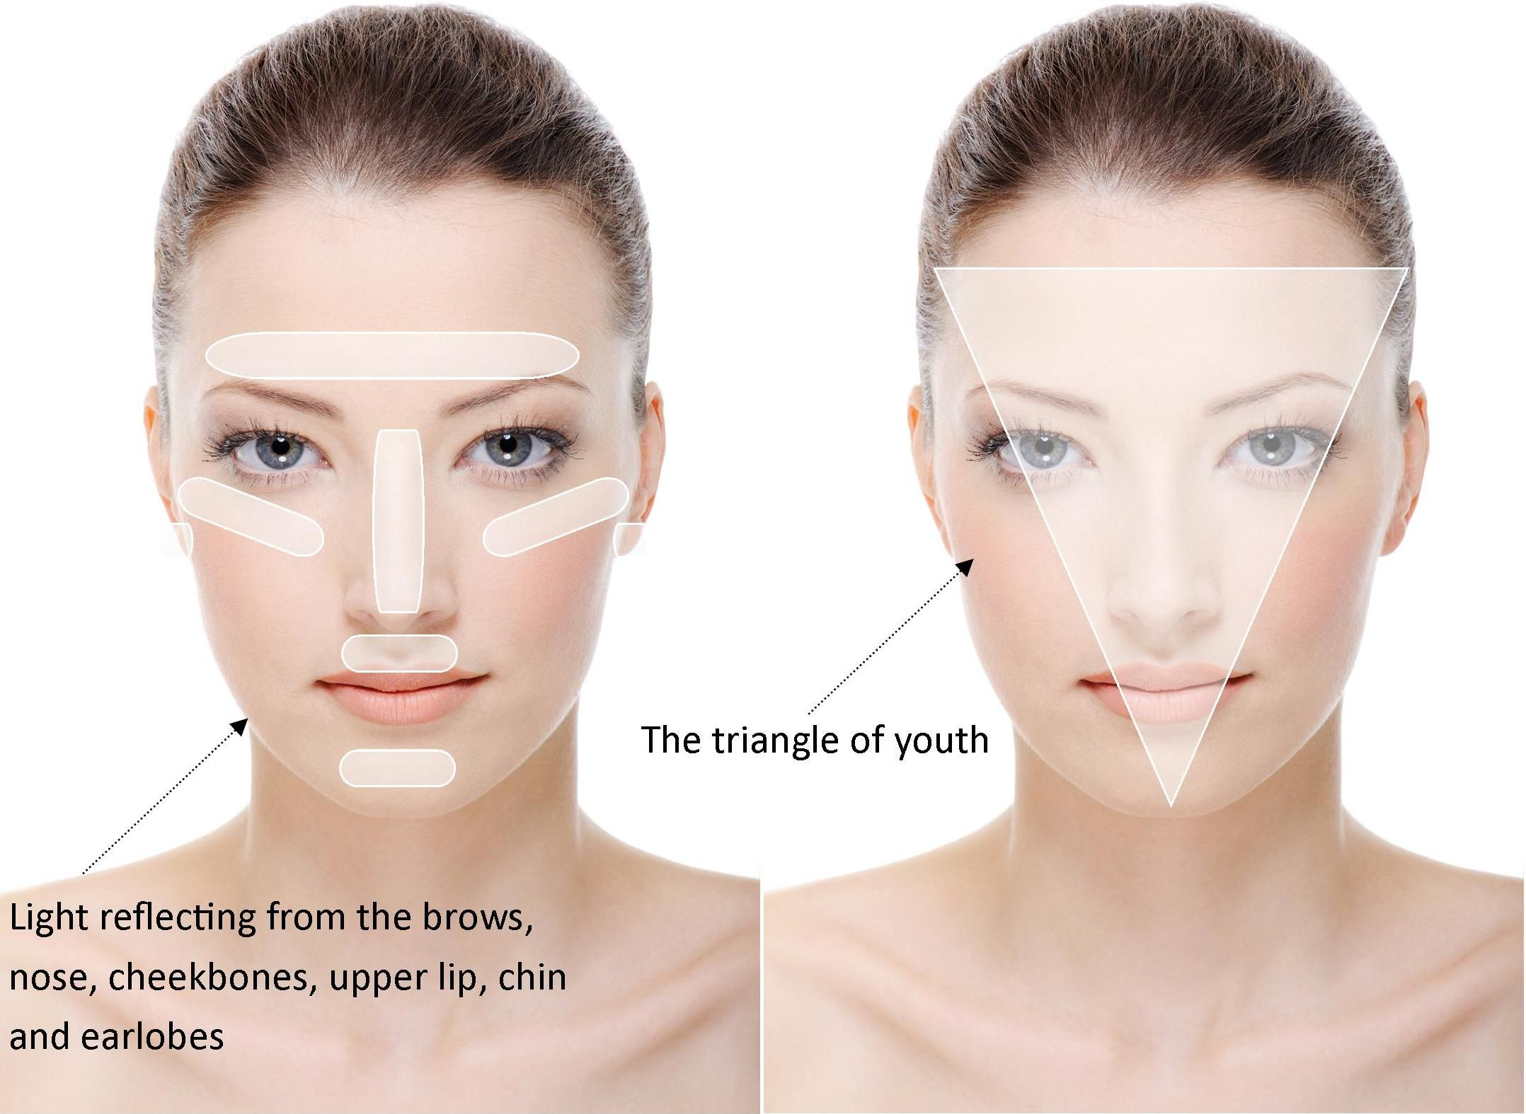
The image on the left is a great guide for where you want the most coverage (sweep foundation on those areas) and then blend outward.
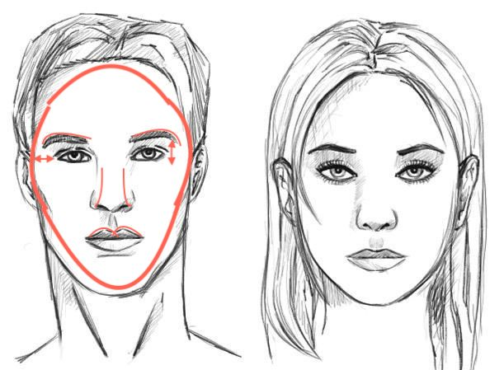

To feminize a male face we want to reshape the face. Men have less space between the brow/eye and the temple/eye so we want to make those areas look larger.
Grooming brows will make a big difference and drawing them out toward the temple. Pull foundation/concealer out toward the outside of eye to give the illusion of a wider space.
A slight over draw of the top lip and nose contour (optional)
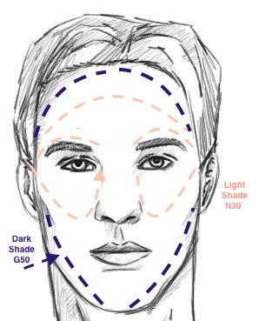
Foundation/Contour

- Smooth darker foundation (CoverFx G40) where diagramed above and blend out with your 231 Wide foundation brush (cat paw).
- Smooth lighter foundation (CoverFx N35) in the triangle under the eye, along the center of the nose, over the brows, under the nose and then blend.
- Take a clean face sponge and bounce over skin to press into skin without moving pigment into the light/darker areas.
- Set the light area with Maybelline FIT loose powder in Fair and the shaded areas with the deep loose powder (with sponge, or blush brush)

I watched several videos that used a peach corrector over the beard then stippled on foundation to cover the blue from hair follicles. I added a NYX corrector palette on the shopping list that would be good for any corrector options (under eye corrector, highlight).

Cheek

- Dip the tips of your blush brush into the brown-peach blush of your BH Cheek palette and run up along the cheekbones. Blend down the plane of your cheek bones to soften the edges so there is no harsh line.
- We didn’t use bronzer because I liked the deep settting powder instead. However, either a matte bronzer of the setting powder could be apply under the cheekbone for more definition.

- Optional. Sweep a highlight over the tops of cheekbone with your setting brush.

Brows
- Fill in the head of the brow with feathery strokes and brush through with spoolie. Then perfect the top and bottom line of the brow with longer strokes and a little more pressure. Be sure to step back from the mirror to see how the brow looks and brush through hairs with spoolie to blend.
- Optional: set with clear brow gel

Eyes  Basic Eye  - Apply Burt’s Bees cream eye shadow over the lid with fingers and blend into the crease and fade out in the underbrow area. Use medium shadow brush to blend out the edges if needed  - Take a medium shadow from your Morphe palette (like the bottom left corner) on your essential crease brush and apply through the entire eye crease. The pigment should fade to light when you get closer to the inner corner. Blend out the edges with any clean shadow brush.  - Pencil Eye Liner. Gently pull skin above your brow to lift your lid, look down your nose with your chin up and smooth the side of your pencil liner over the middle of eye lid out. Use your angled liner brush to perfect line and do the outer flick.  - Eyeshadow Liner. Wet angled liner brush and dip into a dark powder shadow from Morphe palette. Start from the center of the eye and work out. Thinly pull line toward the inner eye. | 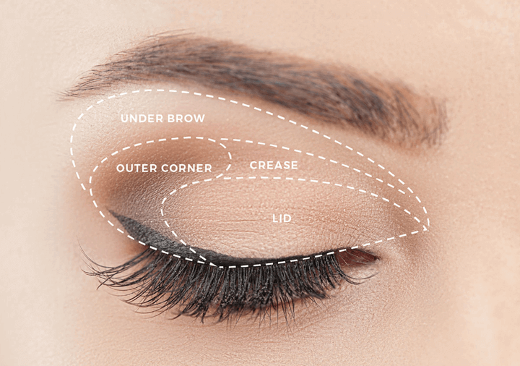
- Optional: Add a pop of shimmer shadow above the center of eye with your shading brush.

Glam up  - Basic Steps 1-5  - Take a medium to dark brown powder shadow on your essential crease brush or shading brush (tap of excess) and layer over the outer corner and crease. Blend edges out with a clean shadow brush.  - Take same powder shadow onto the tips of your smudge brush and blend into the lower lash line placing the majority of the pigment in the outer corner. | 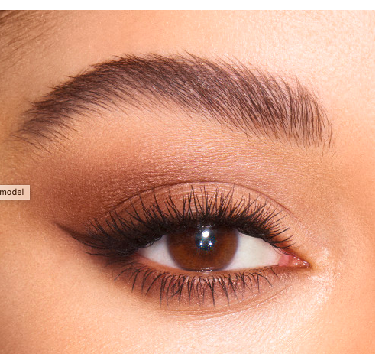

Basic Concealer/Finish
- Use a cotton swab and moisturizer to ‘clean up” any fallen shadow and sharpen the flick of your eye liner.
- Sweep your creamy concealer under eye, into the inner corner of your eye/nose and out toward the outer brow. Blend in with your expert crease brush.

- Use a sheer translucent powder on the tips of your setting brush to set concealer.

Lip Options

- Line lips with a nude lip pencil and slightly overdraw the top lip (especially the cupid’s bow)
- Top with any color. We used Bobbi Brown Blue Raspberry. But they’re a myriad of similar shades I added MAC Fast Play to your shopping list which is very similar.

Touch-up
Whether you’re touching up your makeup for evening or starting fresh, follow these steps for extra coverage.

- Refresh your makeup with a pressed powder compact (or sheer powder if you’re at home) use a sponge or brush over areas that are shiny or red (usually the center of the face)
- For evening, apply another layer of eyeshadow, redo liner, thicken eyebrows or extend the tail portion, and apply under eye concealer.
- After eye makeup touches, sweep concealer under your eyes and over the top of your
- Add a pop of blush and run a subtle highlight over the top of your cheekbones.

Product List
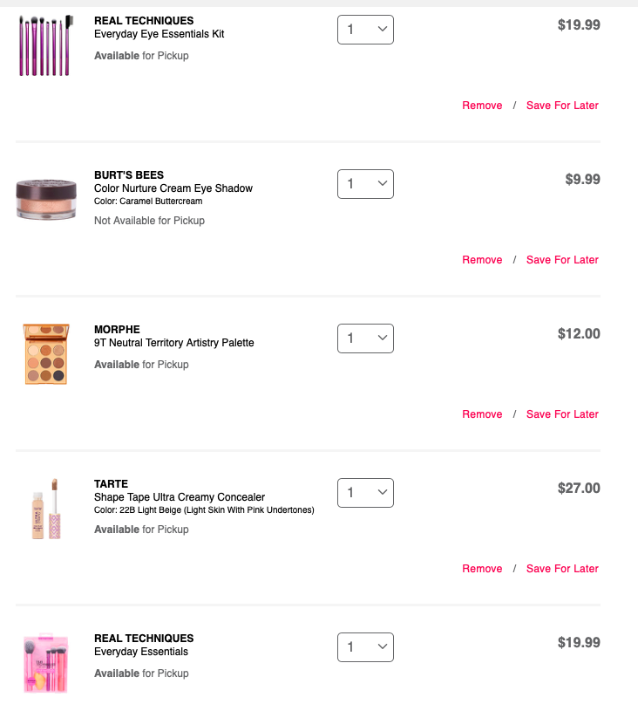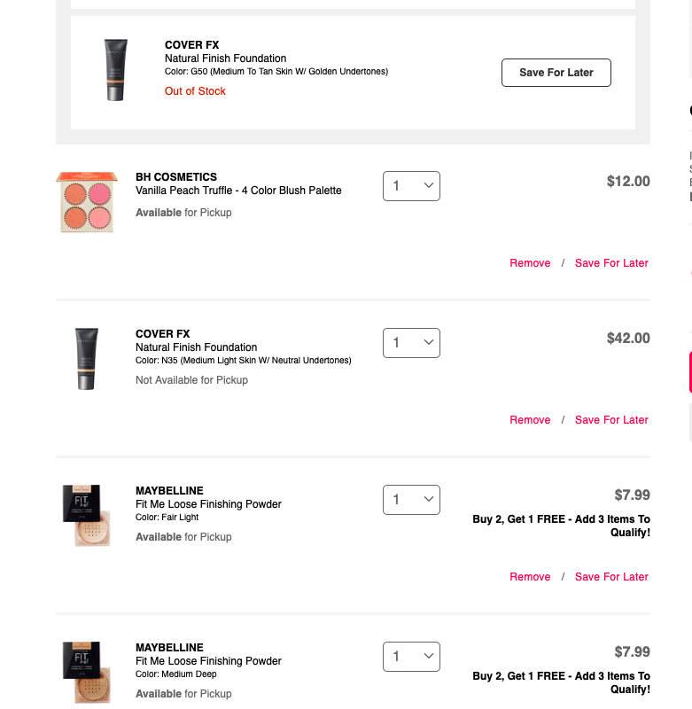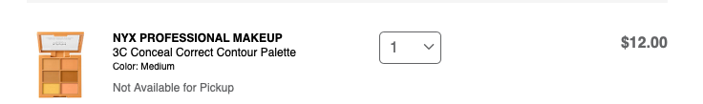

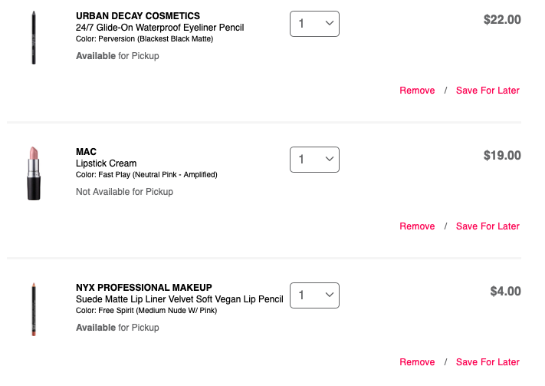
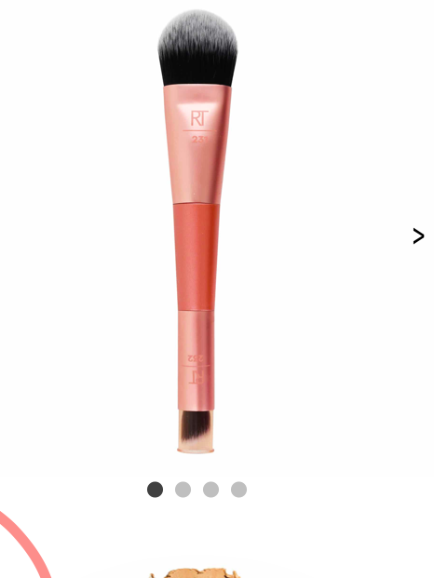

https://realtechniques.com/product/cover-conceal/

